# Press release

**New in Ras Al Khaimah: the first authorised HYPOXI®-Studio - Ladies Only!**

Straß im Attergau, September 2023

**On August 25th, 2023, the first HYPOXI®-Ladies-Studio Ras Al Khaimah opened its doors.**

Owner Juliane Knips, an enthusiastic user for a long time, has known the HYPOXI-Method® for 20 years and has fulfilled her long-awaited dream of opening her own HYPOXI®-Studio. With a "Ladies Only" studio, she is bringing the unique HYPOXI-Method® to Ras Al Khaimah for the first time.

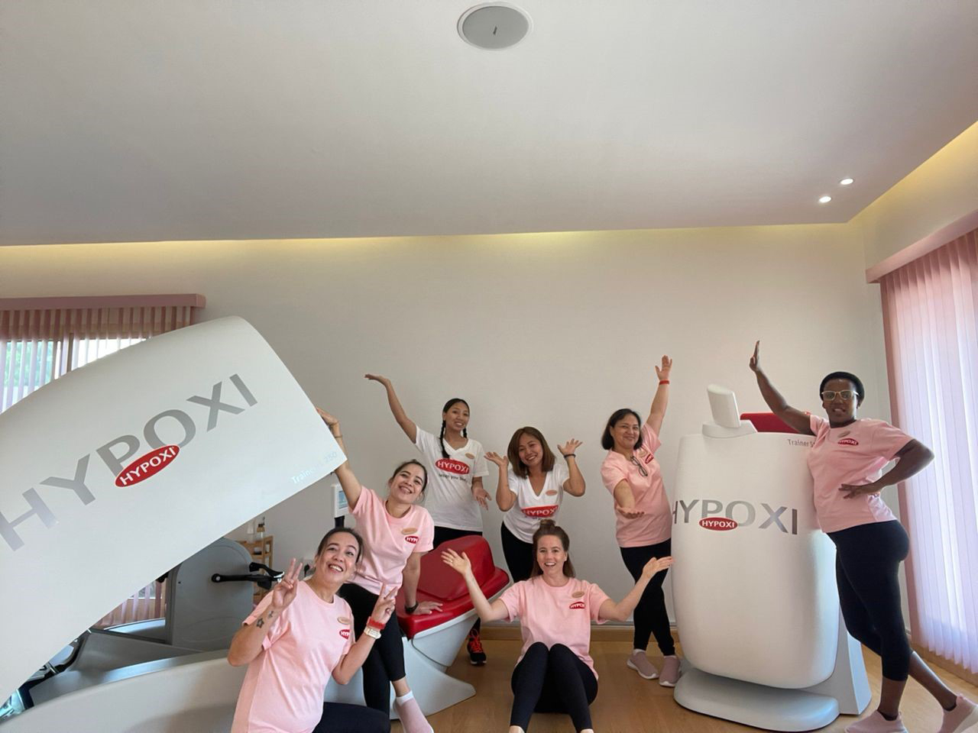 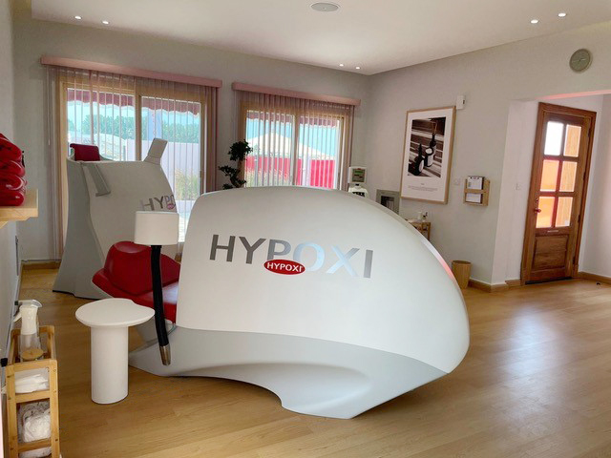

She deliberately did without TV screens in the studio to create a natural, feel-good oasis where you can enjoy healthy tea or infused water in conversation with like-minded people or learn about the latest fashion and health trends while reading one of the international vintage magazines.

In addition to targeted figure shaping with the HYPOXI-Method®, Juliane Knips exclusively offers cosmetic products from the German brand 'BABOR' in her studio.

Babor has been setting standards in medical skin care since 1956 and places the highest value on sustainability and professionalism. Babor is known for highly effective and individual solutions for every skin type and is recommended by dermatological experts worldwide!

The perfect combination to HYPOXI-Training®.

**The HYPOXI® devices at a glance:**

|  |  |
| --- | --- |
|  | **HYPOXI-Trainer® S120**  The S120 combines the three components of HYPOXI-Method® effectively: The computer-controlled alternation of high and low pressure takes place in a chamber that reaches up to the hips. The gentle exercise takes place sitting on the integrated bicycle ergometer. This puts the problem areas – hip, underbelly, buttocks and legs - under pressure, facilitates the activity of the veins and eliminates fat in a targeted manner. |
|  | **HYPOXI-Trainer® L250**  The L250 permits the alternating application of low-pressure for the underbelly, hip, behind and legs. The comfortable reclined position relieves the body of most of its weight during training and promotes the elimination of liquids and toxins. The results are beautiful, slender legs and a visible reduction of cellulite. |
|  | **HYPOXI-Vacunaut®**  The Vacunaut is used to reduce the girth of the stomach and hips. Training is performed in the HYPOXI®-PressureSuit with an integrated network of 122 high and low pressure chambers.  During moderate exercise - which can take place on a treadmill, exercise bicycle or other popular cardiovascular exercise equipment - the application of high and low pressure targets the abdomen and hips. |
|  | **HYPOXI® HD-Comfort**  In order to remain firm and strong the skin needs special treatments. 400 active vacuum chambers integrated in the problem areas in HYPOXI® HD-PressureSuit ensure that the skin gets the exercise it needs. A comfortable lounge chair with integrated high and low-pressure technology ensures pleasant relaxation while the elastic connective fibres of the skin work diligently to achieve smooth, firm skin. |

Released for publication

For more information, please visit www.hypoxi.com.